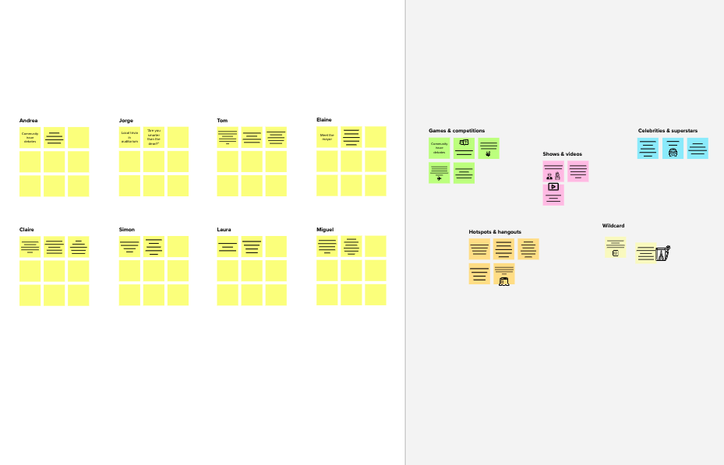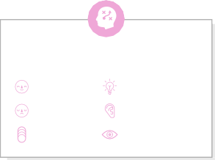

# Brainstorm

**TIP**

You can select a sticky note and hit the pencil [switch to sketch] icon to start drawing!

## Before you collaborate

A little bit of preparation goes a long way with this session. Here’s what you need to do to get going.

**10 minutes**

**1**

## Define your problem statement

What problem are you trying to solve? Frame your problem as a How Might We statement. This will be the focus of your brainstorm.

**5 minutes**

**2**

## Brainstorm

Write down any ideas that come to mind that address your problem statement.

**10 minutes**

**3**

## Group ideas

Take turns sharing your ideas while clustering similar or related notes as you go. Once all sticky notes have been grouped, give each cluster a sentence-like label. If a cluster is bigger than six sticky notes, try and see if you and break it up into smaller sub-groups.

**20 minutes**

**4**

## Prioritize

Your team should all be on the same page about what's important moving forward. Place your ideas on this grid to determine which ideas are important and which are feasible.

**20 minutes**

## After you collaborate

You can export the mural as an image or pdf to share with members of your company who might find it helpful.

# & idea prioritization

should recognize handwriting accurately

should identify correctly

existing styles also recognize while including new styles

**PROBLEM**

**How might we can make a system that will recognize the handwriting from image and display in text ?**

1. **Team gathering**

**Israth raihana**

**Gayathri**

**Kavitha**

**Gomathi**

#### accuracy

user friendly

**Quick add-ons**

Define who should participate in the session and send an invite. Share relevant information or pre-work ahead.

**TIP**

Add customizable tags to sticky notes to make it easier to find, browse, organize, and categorize important ideas as themes within your mural.

should recognize

should be

should

easily

should

should train

should accept

should trained in different

should include

existing styles also recognize

should provide in

should do good

**A Share the mural**

**Share a view link** to the mural with stakeholders to keep

should do good processing of image

1. **Set the goal**

Think about the problem you'll be focusing on solving in the brainstorming session.

1. **Learn how to use the facilitation tools**

Use the Facilitation Superpowers to run a happy and

handwriting accurately

user

friendly

have more

data

accessible

should user friendly by means of given the image and get an proper text

identify

correctly

various

patterns

different styles languages in new upgrades

of handwriting different styles when needed

should recognition the signature

while including proper text

new styles format

processing of image

#### performance

should do

should trained in different languages in different styles

#### acceptance

should trained in different languages in different styles

them in the loop about the outcomes of the session.

**B Export the mural**

Export a copy of the mural as a PNG or PDF to attach to emails, include in slides, or save in your drive.

**10 minutes** to prepare

**1 hour** to collaborate

**2-8 people** recommended

productive session.

[**Open article**](https://support.mural.co/en/articles/2113740-facilitation-superpowers)

### Key rules of brainstorming

To run an smooth and productive session

**Person 5**

|  |  |  |
| --- | --- | --- |
|  |  |  |
|  |  |
|  |  |  |

**Person 6**

|  |  |  |
| --- | --- | --- |
|  |  |  |
|  |  |
|  |  |  |

**Person 7**

|  |  |  |
| --- | --- | --- |
|  |  |  |
|  |  |
|  |  |  |

**Person 8**

|  |  |  |
| --- | --- | --- |
|  |  |  |
|  |  |
|  |  |  |

good processing of image

should identify correctly

existing styles also recognize while including new styles

should include new upgrades when needed

should trained in different languages in different styles

should trained in different languages in different styles

should trained in different languages in different styles

existing styles also recognize while including new styles

### Keep moving forward

**Strategy blueprint**

Define the components of a new idea or strategy.

[**Open the template**](https://app.mural.co/template/e95f612a-f72a-4772-bc48-545aaa04e0c9/984865a6-0a96-4472-a48d-47639307b3ca)

**Customer experience journey map**

Stay in topic. Defer judgment.

Encourage wild ideas. Listen to others.

### Importance

If each of these

should identify correctly

should recognize handwriting

Understand customer needs, motivations, and obstacles for an experience.

[**Open the template**](https://app.mural.co/template/b7114010-3a67-4d63-a51d-6f2cedc9633f/c1b465ab-57af-4624-8faf-ebb312edc0eb)

should include new upgrades when needed

Go for volume. If possible, be visual.

tasks could get

done without any difficulty or cost, which would have the most positive impact?

accurately

existing styles also recognize while including new styles

**Strengths, weaknesses, opportunities & threats**

Identify strengths, weaknesses, opportunities, and threats (SWOT) to develop a plan.

|  |  |
| --- | --- |
|  |  |
|  |  |

[**Open the template**](https://app.mural.co/template/6a062671-89ee-4b76-9409-2603d8b098be/ca270343-1d54-4952-9d8c-fbc303ffd0f2)

Team ID- PNT2022TMID20840

Team Members – Bharathraj R

Manoj E

Narenderan S

Sakthivel M

**TIP**

Participants can use their cursors to point at where sticky notes should go on the grid. The facilitator can confirm the spot by using the laser pointer holding the **H key** on the keyboard.

[**Share template feedback**](https://muralco.typeform.com/to/CiqaHVat?typeform-source=app.mural.co)

[**Share template feedback**](https://muralco.typeform.com/to/CiqaHVat?typeform-source=app.mural.co)

### Feasibility

Regardless of their importance, which tasks are more feasible than others? (Cost, time, effort, complexity, etc.)

**Template**

**Need some inspiration?**

See a finished version of this template to kickstart your work.

[**Open example**](https://app.mural.co/template/e5a93b7b-49f2-48c9-afd7-a635d860eba6/93f1b98d-b2d2-4695-8e85-7e9c0d2fd9b9)